**Iteration 1 – Week 1**

**Austin Mitchell** – 100946390

**Nicholas Rivard** – 100650469

**Ahmed Abdelghani** – 100756152

**Graphical User Interface**

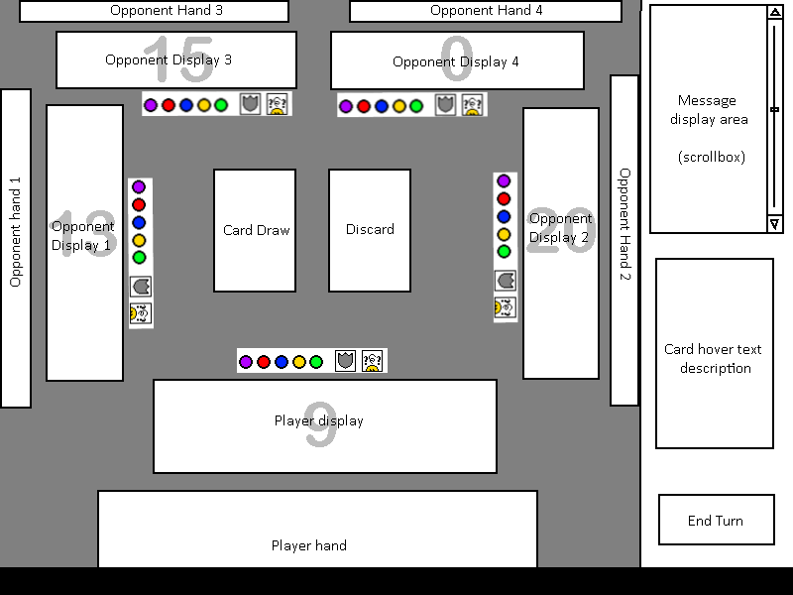

**Start Screen**

This opening screen allows the player to type in the IP they wish to connect to

(or use the default IP hardcoded) and connect to that server. If they connect, then

move on to the Game Setup Screen

**Game Setup Screen**

**Setup**

If you were the first to connect to the server, you get to set the conditions

for the game. You choose the number of players, and once enough players connect

then the game begins

**Joining**

If you were not the first to connect to the server, then this screen will

display until the number of players has been selected and enough players have

joined

**Main Game**

*NOTE: The plan is to have a different layout according to the number of players,

though the general idea will remain for each layout. This is the maximal layout with

5 players.

**Play Area**

**Card Draw**

This will be a clickable area to pick up a card, and it will be indicated

at the beginning of each turn that the player should draw

**Discard**

This is simply visual candy, it will display the last discarded card.

**Player/Opponent Display**

This area will display the player's coloured and supporter cards played.

Note that there is a number behind it; the plan is to draw text

representing the display value, which will have around 50% alpha value to

allow us to place two visuals in the same area without too much distraction

Hovering over cards in these displays will bring them to the front and

display a blurb in the "Card Hover Text Description" area

**Player Hand**

This area displays the cards in your hand, and will be clickable to play

cards, and hovering over a card will bring it to the front and display a

blurb about it in the "Card Hover Text Description" area

**Opponent's Hand**

These areas are mostly eye candy and are not interactable, they will

simply be for counting the number of cards in a players hand.

Status Bar

Each player has a status bar which will display the tokens they've

collected, and displays an indicator if they are currently shielded or

stunned

*NOTE: The decision for icons to display status was for space conservation.

The real-game equivalent would be to have to card in front of you, but this

should amount to the same thing. The only implication is that there's still

a 'card' representation underneath, in the sense that the special card does

not get immediately tossed into discard, only when the tournament ends. As

there is the potential for 5 players in this game, there is only so much

visual real estate to work with.

Side Bar

Message Display Area

This box stores messages about the game which the player can scroll through

at their leisure. It will say things such as 'X played red 5' or 'X played

Unhorse'.

Card Hover Text Description

When you hover over a card, this area will display a short text description

about the relevant card.

**End Turn**

This button ends your turn, and depending on the value of your display at

the moment will either withdraw you from the tournament or allow you to

continue.

*NOTE: This decision was based on the fact that if you are able to

continue, there is no strategical benifit to withdrawing. The next turn you

could draw a card and withdraw, which would result in the same effect but you

now have an extra card, so the option to withdraw when you can continue was

removed

**Screen Overlay**

If special actions occur (outside of normal game interface), a layout will

cover the main game screen, and must be dealt with before the Main Game UI can

be interacted with again. There are a number of examples:

**Token Selection**

If you win a purple tournament, an overlay will pop up asking you which

colour token you would like. The options will be tokens you do not have.

**Special Cards**

If you play a special card which requires extra interation, then an overlay

will appear, which will be different for each special card. For instance, if

the goal is to steal a card from someone's display, the overlay will show you

the three opponent displays and make them clickable so you can select the

display to use. Change weapon may bring up a screen asking you to select the

colour to switch the tournament to.

**Ivanhoe**

When a special card is played, there will be a delay. Each player will see

that a special card was played, and if a player has an Ivanhoe card then

the UI will also give them an option to use their card.

**Networking**

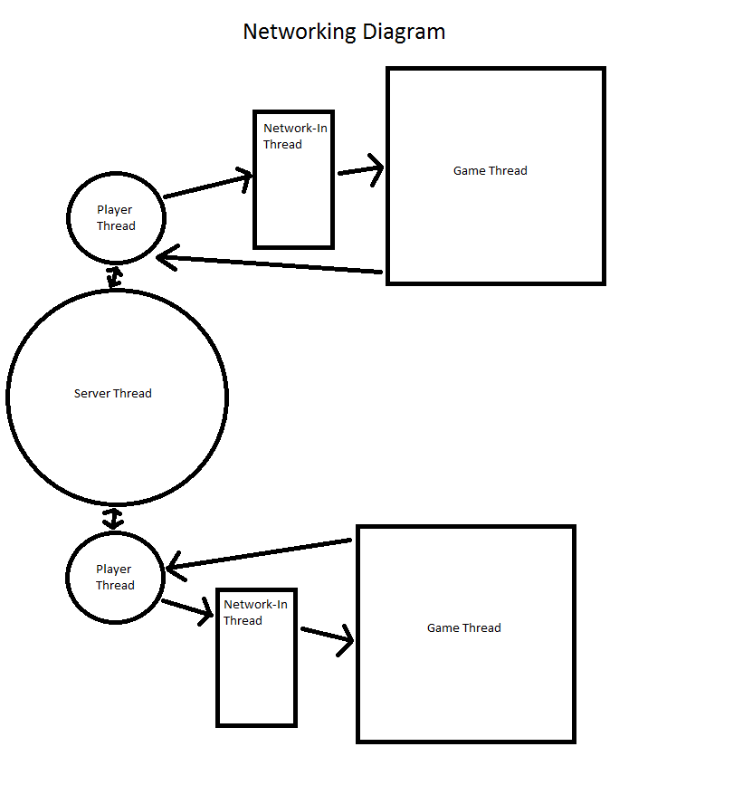

**The Client Program**

The Client is comprised of a Game Thread and a Network-In Thread.

**Game Thread**

This is the main thread of client program which starts when the client program is run.

It is used to initialize the parameters for establishing a network connection with the Server Program.

It spawns the Network-In Thread to enable asynchronous network communication.

It receives game updates from the Network-In Thread which it puts into a sorted buffer.

It contains the graphical user interface and the game engine.

In the game engine there is an update handler and local update counter.

The update handler gets an update from the sorted buffer if its number matches local update counter.

The update handler then processes the update to update local game state and then increments local update counter.

The Game Thread sends game updates to the Server.

It contains a socket for sending locally generated updates to the Server.

It increments local update counter every time a new update is sent.

The automated player logic will also be found in the Game Thread.

**Network-In Thread**

The Network-In Thread contains a socket for continually receiving incoming messages from the Server.

It also contains a buffer for storing received messages until the Game Thread is ready to receive them.

**The Server Program**

The Server is comprised of a Server Thread and one to five Player Threads.

**Server Thread**

The Server Thread contains a listening socket for establishing new connections to Client programs.

It contains a universal update counter.

It spawns a new Player Thread for each new connection to a Client program. There can be one to five Player Threads.

It coordinates communication between the Player Threads.

It receives incoming update messages from the current Player Thread and updates the universal update counter.

It sends received update messages to all non-current Player Threads.

**Player Thread**

The Player Thread contains a current variable which indicates if it is that player's turn.

It contains a socket for sending and receiving update messages from the corresponding Client Network-In Thread.

When a Player Thread is current, it receives new update messages from the corresponding Client Network-In Thread.

It then sends received update message to the Server Thread.

When a Player Thread is not current, it receives pending update messages from the Main Thread.

It then sends pending update messages to corresponding Client Network-In Thread.

**Work Distribution**

The work can be generally separated into 3 different categories:

* GUI
* Networking
* Rules Engine

Our plan for workflow will reflect this distribution. Although we are all responsible for the entirety of the project being developed, each member will be more responsible for the development of each section. The Distribution is as follows:

**Austin Mitchell** – GUI

**Nicholas Rivard** – Networking

**Ahmed Abdelghani** – Rules Engine

**User Stories (written in Gherkin format)**

Feature: Winning a Tournament

# As a player

# I want to be the last player to withdraw from tournaments

# So that I can earn tokens, and win the game

Scenario: Player wins a tournament and receives their fifth token with less than four players

Given a player has won a colour tournament they have not already won

And there are less than four players total

When the player takes a token

And the player now has five tokens

Then the player has won the game

Scenario: Player wins a tournament and receives their fourth token with at least four players

Given a player has won a colour tournament they have not already won

And there are at least four players total

When the player takes a token

And the player now has four tokens

Then the player has won the game

Scenario: Player wins any non purple tournament have not won this tournament yet

Given a player is the last one to withdraw from a tournament

When the player wins the tournament

And the tournament was not purple

And they have not won this colour tournament

Then the token the player recieves is the colour of the tournament

Scenario: Player wins any non purple tournament have already won

Given a player is the last one to withdraw from a tournament

When the player wins the tournament

And the tournament was not purple

And the player has already won this colour tournament

Then the player does not receive a token

Scenario: Player wins a purple tournament and has not done so yet

Given a player is the last one to withdraw from a purple tournament

When the player wins the tournament

And the player has not already won a purple tournament

Then the player may receive any token they do not already have

Scenario: Player wins a purple tournament and has already won a purple tournament

Given a player is the last one to withdraw from a purple tournament

When the player wins the tournament

And the player has already won a purple tournament

Then the player may receive any non-purple token they do not already have

Feature: Starting A Tournament

# As a player

# I want to choose a colour for the tournament

# So that the rules for the tournament can be established

Scenario: Player has coloured cards of each colour and no supporters

Given the player starts a tournament

When the player draws a card

And the player has coloured cards of each colour

And the player has no supporter cards

And the last tournament was not purple

Then the player can start a tournament in any colour

Scenario: Player has coloured cards of each colour and no supporters after a purple tournament finished

Given the player starts a tournament

When the player draws a card

And the player has coloured cards in each colour

And the player has no supporter cards

And the last tournament was purple

Then the player only start a tournament in any non-purple colour

Scenario: Player has coloured cards and no supporters

Given the player starts a tournament

When the player draws a card

And the player has coloured cards

And the player has no supporter cards

And the last tournament was not purple

Then the player can start a tournament in any colour they have

Scenario: Player has coloured cards and no supporters after a purple tournament finished

Given the player starts a tournament

When the player draws a card

And the player has coloured cards in at least one non-purple colour

And the player has no supporter cards

And the last tournament was purple

Then the player only start a tournament in any non-purple colour they have

Scenario: Player's coloured cards are only purple and no supporters after a purple tournament finished

Given the player starts a tournament

When the player draws a card

And the player has coloured cards of only purple

And the player has no supporter cards

And the last tournament was purple

Then the player cannot start a tournament

And the next player starts a tournament

Scenario: Player has supporter cards

Given the player starts a tournament

When the player draws a card

And the player has a supporter card

And the last tournament was not purple

Then the player can start a tournament in any colour

Scenario: Player has supporter cards after a purple tournament finished

Given the player starts a tournament

When the player draws a card

And the player has a supporter card

And the last tournament was was purple

Then the player can start a tournament in any non-purple colour

Scenario: Player has no coloured cards and no supporters

Given the player starts a tournament

When the player draws a card

And the player has no cards of any colour

And the player has no supporters

Then the player cannot start a tournament

And the next player starts a tournament

Feature: Starting a new game

# As a player

# I want the game to be initialized properly

# So that play can begin

Scenario: Player draws a non-purple token when deciding the first player

Given that a new game is beginning

When a player draws a token at random

And the drawn token is not purple

Then the player is not the first to start a tournament

And the token is placed back into the pool

Scenario: Player draws a purple token when deciding the first player

Given that a new game is beginning

When a player draws a token at random

And the drawn token is purple

Then the player is the first to start a tournament

And the token is placed back into the pool

Feature: Player wishes to play a action card

# As a player

# I want to use action cards to my advantage

# So I can help myself win tournaments or prevent opponents from doing the same

Scenario: Player plays Unhorse

Given it's a player's turn

And the tournament is purple

When the player plays Unhorse

Then the player can change the tournament to red, yellow or blue

Scenario: Player plays Change Weapon

Given it's a player's turn

And the tournament is red, yellow or blue

When the player plays Change Weapon

Then the player may change the tournament to red, yellow or blue

And the resulting tournament colour is different from the original

Scenario: Player plays Drop Weapon

Given it's a player's turn

And the tournament is red, yellow or blue

When the player plays Drop Weapon

Then the tournament colour becomes green

And the new values for player displays will reflect this

Scenario: Player plays Break Lance

Given it's a player's turn

And it is a purple tournament

When the player plays Break Lance

And the opponent does not have Shield

Then the player selects one opponent

And the opponent's display contains purple and non-purple cards

And the opponent discards all purple cards in his/her display

Scenario: Player plays Riposte

Given it's a player's turn

When the player plays Riposte

And the opponent does not have Shield

Then the player selects one opponent

And the opponent loses the last played card in his/her display

And the player adds that card to his/her display

Scenario: Player plays Dodge

Given it's a player's turn

When the player plays Dodge

And the opponent does not have Shield

Then the player selects an opponent

And the player selects a card to discard from the opponent's display

Scenario: Player plays Retreat

Given it's a player's turn

When the player plays Retreat

And the player has more than one card in his/her display

Then the player selects any one card from his/her display

And the player gets that one card back to his/her hand

Scenario: Player plays Knock Down

Given it's a player's turn

When the player plays Knock Down

And the opponent does not have Shield

Then the player selects one opponent

And a random card is removed from the opponent's hand

And the card is added to the player's hand

And the card is not shown to the other players

Scenario: Player plays Outmaneuver

Given it's a player's turn

When the player playes Outmaneuver

And the opponent does not have Shield

Then each opponent loses the last card played in his/her display

Scenario: Player plays Charge

Given it's a player's turn

When the player plays Charge

And the opponent does not have Shield

Then the lowest value card throughout all displays is identified

And all opponents must discard all cards of this value from their displays

Scenario: Player plays Countercharge

Given it's a player's turn

When the player plays Countercharge

And the opponent does not have Shield

Then the highest value card throughout all displays is identified

And all opponents must discard all cards of this value from their displays

Scenario: Player plays Disgrace

Given it's a player's turn

When the player plays Disgrace

And the opponent does not have Shield

Then all supporter cards are removed from all opponents' displays

Scenario: Player plays Adapt

Given it's a player's turn

When the player plays Adapt

And the opponent does not have Shield

Then each opponent must keep only one card of each value in their display

And all other cards are discarded

Scenario: player plays Outwit

Given it's a player's turn

When the player plays Outwit

Then the player any of his/her faceup cards infront of any opponent

And the player takes any one card from that opponents faceup cards

Feature: Player wishes to play a Special Action card

# As a player

# I want to use Special Action cards

# So that it helps me win the tournament and protects me from losing

Scenario: Player plays Shield

Given it's the player's turn

When the player plays Shield

Then Shield is placed faceup separately from the player's display

And the player is not affected by any Action card except the Outwit card

Scenario: Player plays Stunned card

Given it's the player's turn

When the player plays a Stunnned card against an opponent

Then the card is placed infront of the opponent faceup separately from the opponent's display

And the opponent is unable to play more than one card in each turn

And no action card can remove Stunned except the Outwit card

Scenario: Player plays Ivanhoe

Given it is the opponent's turn

And the player has an Ivanhoe card

When the opponent plays an action card against the player

Then the player can instatnly play Ivanhoe

And the action card played against the player will not have any effect

Feature: Player wishes to play colour or supporter cards

# As a player

# I want to increase my display area's value

# So that I can remain in the tournament

Scenario: Player can play a number of coloured cards

Given it is the player's turn

When the player draws a card

And the player has a number of cards of the same color as the tournament color

And the player does not have a faceup Stunned card

And the sum of the player's display combined with playable caoloured cards create the highest display value

Then the player can play one or more cards of that color in the same turn

Scenario: Player can play a number of supporter cards with no Maiden in player's display

Given it is the player's turn

When the player draws a card

And the player has a number of supporter cards

And the player does not have a maiden in his/her display

And the player does not have a faceup Stunned card

And the sum of the player's display combined with playable supporter cards create the highest display value

Then the player can play a number of supporter cards

Scenario: Player can play a number of supporter cards and a Maiden is in the player's display

Given it is the player's turn

When the player draws a card

And the player has a number of supporter cards

And the player has a maiden in his/her display

And the player does not have a faceup Stunned card

And the sum of the player's display combined with playable non-maiden supporter cards create the highest display value

Then the player can play one or more non-maiden supporter cards

Scenario: The player stays in the tournament with a faceup Stunned card infront of him/her

When the player has one or more playable cards

And the player has a faceup card infront of him/her

And the player has a playable card that would render his/her display the highest value

Then the player is able to play that one card and stay in the tournament

And the player cannot play more than one card

Scenario: The player cannot stay in the tournament with a faceup Stunned card infront of him/her

When the player has one or more playable cards

And the player has a faceup card infront of him/her

And the player does not have a playable card that would render his/her display the highest value

Then the player has no choice but to withdraw from the tournament

Scenario: Player plays cards but cannot continute in the tournament

Given it is the player's turn

When the player draws a card

And the player does not have a faceup Stunned card

And the player plays one or more playable cards

And the total display value of the player is still less than the highest display value

Then the player has no choice but to withdraw from the tournament

And the player loses all cards that s/he has played in the display

Scenario: Player cannot play any cards

Given it is the player's turn

When the player draws a card

And the player does not have cards of the same color as the tournament

And the player does not have supporter cards

And the player does not have action cards that can be played

Then the player is forced to withdraw from the tournament

Feature: Player has a action card played against him/her

# As a player

# I had a action card played against me

# The action card would remove some cards in my display

Scenario: action card played against the player where it does not remove all the display cards

Given a action card is played against the player

When the action card would remove one or more cards from the display

And the action card would not leave the display empty

Then the action card function normally

Scenario: action card played against the player where it removes all the display cards

Given a action card is played against the player

When the action card would remove one or more cards from the display

And the action card would cause the player's display to be empty

Then the action card cannot remove the earliest played value card in the player's display

And the action card would remove everything else

Scenario: Outwit card played against the player where it can swap his/her only card in the display area

Given an Outwit card is played against the player

When the player only has one card in display area

And the opponent chose to swap a value card with the player's card

Then the Outwit card can function normally

Scenario: Outwit card played against the player where it cannot swap his/her only card in the display area

Given an Outwit card is played against the player

When the player only has one card in display area

And the opponent chose to swap a non-value card with the player's card

Then the opponent cannot successfully swap cards